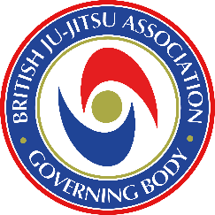

Application Form
National Governing Body Coaching Awards

Name:

Age:

Grade:

BJJAGB Membership No.

Address;

Telephone:

Email:

New Award, Upgrade or Renewal (Tick which Applies)

N.B.No levels can be missed
eg If a 1st Dan has not previously completed Levels 1&2 all levels must be completed

Level 1 (Novice Coach) Purple Belt £75
Level 2 (Assistant Coach) Brown Belt £100
Level 3 (Club Coach) 1st Dan £125
Level 4 (Senior Coach 3rd Dan and Above £150

Renewal all Levels £101

Payments to be made via the links on the BJJAGB Website www.bjjagb.com/coaching-course

Please send completed form to coachingcoordinator@icloud.com

On receipt of this form, Current 1st Aid, DBS certificates and payment to the BJJAGB you will be contacted by the Coaching Director who will advise criteria to be completed prior to the course.

Please Note: All applicants must be nominated by their Head of Association or Lead Coach

Applicants Signature and Date

